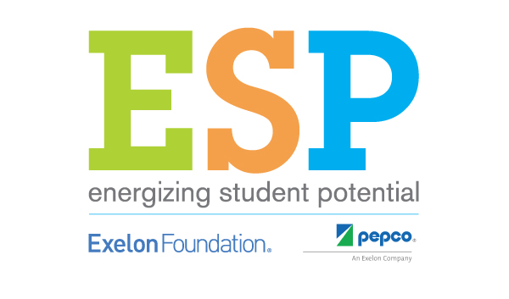

FOR IMMEDIATE RELEASE

Media Contacts
For the school:
For the program: Mary Spruill, 800-875-5029

Media Advisory: Energizing Student Potential Energy Fair to be Hosted at (Insert School) on (Insert Date)

WHAT: The first-of-its-kind program, Energizing Student Potential is a program supported by the Exelon Foundation, and Pepco Holdings. This hands-on, STEM focused energy program provides students in grades 5-8 the opportunity to explore energy in STEM and to share their knowledge with the local community. Each Energizing Student Potential school is hosting an Energy Fair for its local community.

WHERE: (Insert School)
(Insert location at school and school address)

WHEN: (Insert Date and Time)

WHO: Energizing Student Potential lead teachers (insert teacher names) and (his/her) students will be hosting the (insert school) Energy Fair. Energy Fair activities include:

- Six Games from NEED’s Energy Carnival

- Facts of Light station and information that includes light bulb comparisons for students and those attending the Energy Fair

- Energy House – Lessons for a small group of students to build and demonstrate an energy efficient home.

- Energy Linked In Designs – Students will create Linked In pages for themselves using career information from all partners in order to learn more about natural gas, electric power, refining, petroleum, nuclear, renewables and more.

- Energy Information Exhibits– Students will create informational exhibits for attendees to tour. Topics will include:
  - Energy Efficiency and Conservation
  - Nuclear Energy
  - Petroleum
  - Natural Gas
  - Transportation Fuels
  - Electricity
  - Heating and Cooling
  - Hot Water Heating
  - Lighting
  - Wind
  - Solar
  - Plug Loads

###
About Energizing Student Potential
Energizing Student Potential (ESP) is sponsored by Pepco and the Exelon Foundation, aims to engage and encourage the future scientists and engineers who will make up the energy workforce of tomorrow. Working with the National Energy Education Development (NEED) project, ESP provides a full suite of programs that foster passion for science, technology, engineering and math in 5th through 8th grade students and provide teachers the tools they need to reach this goal. ESP will serve 80 diverse schools throughout the Pepco service area and produce measurable outcomes in advancing STEM.

