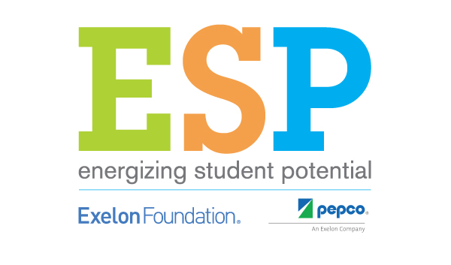

MULTIMEDIA PERMISSION
(all participants must complete)

I give my permission for audio recordings/snapshots/videos of my child participating in Energizing Student Potential activities to be used in multimedia promotions such as brochures, newsletters, program videos, social media, and/or the NEED, or partner, websites.

Parent/Guardian Signature: ____________________________________________________

Print Name: __________________________________________________________________

Phone Number: ( ) _______________Cell Phone: ___________________________

Email: __________________________________________________________________________

Date: _______________________________________

